**ECE 385**

Fall 2018

# *Final Project Proposal*

# 

Angela Park - aspark4@illinois.edu

Mihir Kumar - mkumar12@illinois.edu

Section: AB7 (Friday 11:00AM-1:50PM)

TA: Hadi Asghari-Moghaddam,

Vikram Anjur

**Idea and Overview**

We propose to design and implement a multiplayer version of the popular arcade game “Tetris” using the hardware skills acquired during ECE 385. The hardware components for this lab will include the VGA interface, PS/2 keyboard interface, the sound driver, as well as the font sprite.

We will use the protocol we implemented in Lab 8 to interface a VGA monitor with the FPGA board through the VGA port. Because we are no longer using USB protocol, we do not need the software code from Lab 8. Since the PS/2 keyboard interface is written in hardware, our design will end up being pure hardware.

The only additional equipment we need to complete the project and demo is the PS/2 keyboard.

**Block Diagram**

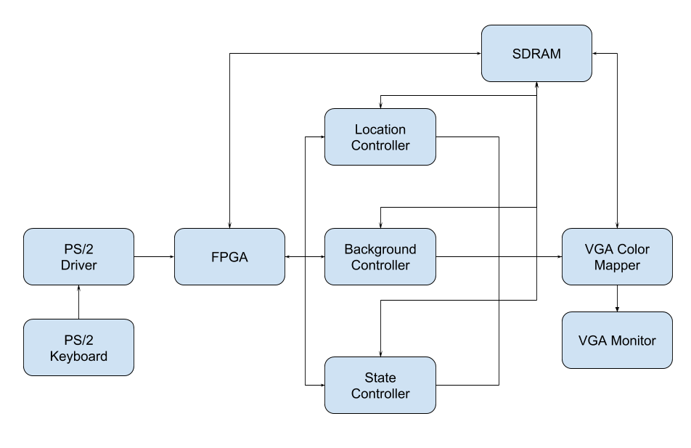

Figure 1. Shows block diagram for our proposed design.

**List of Features**

The baseline set of features for our design to be considered functional would include implementing the basic rules and controls of Tetris. These include being able to rotate the current block, move it along the coordinate axes, and rapidly push it towards the bottom (soft drop and hard drop). We plan to use the HEX displays for keeping track of the score in our initial base game. The game would end when the stack of blocks hits the top border of the window or when the player presses the keyboard key designated for resetting/ending the game.

When the reset/end game key is triggered, the game should go to a “idle state” screen. This screen will display a scoreboard of the top five scores as an added functionality to add “difficulty points” to our project once the base game is completed (see *Expected Difficulty and Justification* section). Once the start key is triggered, the game will leave the idle state screen and start the game.

|  |  |
| --- | --- |
| **KEY** | **FUNCTIONALITY** |
| Enter | Start game |
| Backspace | Reset/end game |
| W (Up) | Rotate block 90 degrees clockwise |
| A (Left) | Move current block to the left |
| S (Down) | Soft drop |
| D (Right) | Move current block right |
| Ctrl | Hard drop |

Table 1. Shows keyboard keys we plan to use for our project and their corresponding functionality.

**Expected Difficulty and Justification**

The expected difficulty for the base Tetris game is expected to be “medium”, which corresponds to a 5/10 on the difficulty range.

However, once we get the base Tetris game working, we plan to add a multiplayer function to the game that allows 2 players to play against each other using the same PS/2 keyboard. We also plan to add music/sound effects to the game using the sound driver code provided on the ECE 385 website. For the base game, since we are displaying the score on the hex drivers, to add complexity once the base game is completed, we will use the font sprite to implement a score tracking system as well as a scoreboard on the VGA monitor. In addition, specific keyboard keys can be designated to start and end the game with different graphics for both game states. If time permits, we will also attempt to add on-screen graphical buttons for starting the game in single player or multiplayer mode and make the animations look smooth. Other ideas we can implement include using double buffering in VGA, shattering cleared blocks rather than simply removing them from view, using different kinds of memories and using a 256 color palette. However, these ideas may or may not be implemented depending on how quickly our project progresses.

**Proposed Timeline**

Week 2/3 - get base game completely debugged and working

Week 2/3 and Week 4 - add difficulty (sound, multiplayer, sprite, etc)

Week 5 - Debugging